Document Details

Title |  |  | GCR05 – Safeguarding Children Policy
Author |  |  | CIC Board
Quay Primary Healthcare CIC ref no: |  |  | GCR05
Version |  |  | 1.9
Approval process
Approved by |  |  |  | CIC Board
Date approved |  |  |  | 04 December 2015
Lead Director |  |  |  | Medical Director
Category |  |  |  | Clinical Governance
Sub Category |  |  |  | Risk Management and Safety
Next Review Date |  |  |  | 15 Feb 2024
Superseded document (If applicable)
Distribution
Who the policy will be distributed to |  |  |  | All Quay Primary Healthcare CIC Team
Method |  |  |  | Email
Version Control
No: | Date | Amendment
1.1 | 01/10/2015 | L. Downey, K. Hastie
1.2 | 07/10/2015 | L. Downey, K. Hastie
1.3 | 25/04/2017 | Changes to make safeguarding children only
1.4 | 04/05/2017 | Addition of Prevent and Lampard Sections
1.5 | 20/05/2018 | Full policy revision following handover of CCA practices
1.6 | 04/05/2020 | Policy review and revision – change of organisation name
1.7 | March 2021 | Update to section 5
1.8 | Nov 2021 | Change of organisation name – Quay Primary Healthcare CIC
1.9 | 15 Feb 24 | Updated contact details for safeguarding children’s team

Section |  | Page Number
1 | Policy Statement | 2
2 | Purpose | 2
3 | Scope | 2
4 | Responsibilities | 3
5 | Reporting Safeguarding Concerns | 3
6 | Allegations of Abuse by Staff | 4
7 | Equality Impact Assessment | 5
Appendix 1 | What to Do if You’re Worried a Child is Being Maltreated | 6
Appendix 2 | Warrington Multi -Agency Assessment and Referral Form | 7
Contents:

- Policy Statement
Quay Primary Healthcare CIC believes that it is always unacceptable for a child or young person to experience abuse of any kind and recognises its responsibility to safeguard the welfare of all children and young people, by a commitment to practice which protects them.

Quay Primary Healthcare CIC recognises that: -
- The welfare of the child/young person is paramount.
- All children and young people, regardless of age, disability, gender, racial heritage, religious belief, sexual orientation or identity, have the right to equal protection from all types of harm or abuse.
- Working in partnership with children, young people, their parents, carers and other agencies is essential in promoting young people's welfare.

- Purpose
The purpose of the policy is:-
- To provide protection for the children and young people who receive services from Quay Primary Healthcare CIC, including the children of adult members or users.
- To provide staff and volunteers with guidance on procedures they should adopt in the event that they suspect a child or young person may be experiencing, or be at risk of, harm.

- Scope
This policy applies to all staff, including senior managers and the Board, paid staff, volunteers and sessional workers, agency staff, students or anyone working on behalf of Quay Primary Healthcare CIC.

Quay Primary Healthcare CIC will seek to safeguard children and young people by: -
- Valuing them, listening to and respecting them.
- Adopting the child protection manual of the Local Safeguarding Children Board for Warrington. This can be found at:

http://www.proceduresonline.com/pancheshire/warrington/index.html

- Sharing information about child protection and good practice with children, parents, staff and volunteers;
- Sharing information about concerns with agencies who need to know, and involving parents and children appropriately;
- Providing effective management for staff and volunteers through supervision, support and training.

- Responsibilities
Safeguarding Lead

Dr Quincy Chuka is the Safeguarding Lead for Quay Primary Healthcare CIC. The Safeguarding lead will
- Have a key role in promoting good professional practice.
- Provide support and advice to those staff involved in supporting children.
- To ensure that a safeguarding children’s training plan is in place.
- By conducting internal case reviews and ensuring that the resulting action plan is followed up, unless substantially personally involved in the case.

Quay Primary Healthcare CIC Board
The Board is responsible for ensuring that the Local Safeguarding Children Board’s policies are adopted and acted upon with the organisation.

All Employees
All employees are responsible for having knowledge of the Local Safeguarding Children Board procedures and for accessing relevant training.

All staff should know how to contact the Named and Designated Professionals for guidance and support.
All staff should keep comprehensive and contemporaneous records of all concerns, discussions and decisions made including telephone conversations.

- Reporting Safeguarding Concern
Any safeguarding concerns regarding the safety and welfare of children must be reported immediately using the designated contact numbers in the Cheshire and Merseyside ICB document “What to do if you are worried a child is being abused” (Appendix 1).

In the event of a child being examined by a Quay Primary Healthcare CIC clinician and NAI being suspected but the need for further examination in an A&E dept is required – transfer to hospital by ambulance is advised.

All complaints that refer to the safety of children will be investigated thoroughly.

- Allegations of Abuse by Staff
Allegations of abuse by staff must be reported to the Safeguarding Children Lead immediately or the Chief Executive in his absence.

The Local Safeguarding Children Board procedures for dealing with allegations of abuse against professional carers must be followed and, if appropriate, the Local Authority Designated Officer (LADO) informed.

http://www.proceduresonline.com/pancheshire/warrington/p_alleg_against_staff.html

Additionally, the allegation must be reported to the Care Quality Commission immediately and must not await the outcome of any investigation.

7. Equality Impact assessment

 |  | YES/NO | COMMENTS
1 | Does the policy/guidance affect one group less or more favourably than another on the basis of; | No
 | - Race/ethnic or national origin/colour/nationality | No
 | - Disability | No
 | - Gender | No
 | - Religion / belief culture | No
 | - Sexual orientation | No
 | - Age | No
 | - Marital status | No
 | - Pregnancy or maternity | No
2 | Is there any evidence that some groups are affected differently? | No
3 | If you have identified potential discrimination, are any exceptions valid, legal and/ or justifiable? | Yes
4 | Is the impact of the policy/ guidance likely to be negative? | No
5 | If so can the impact be avoided? | Yes
6 | What alternatives are there to achieving the policy/ guidance without the impact? | N/A
7 | Can we reduce the impact by taking different action? | N/A

Appendix 1
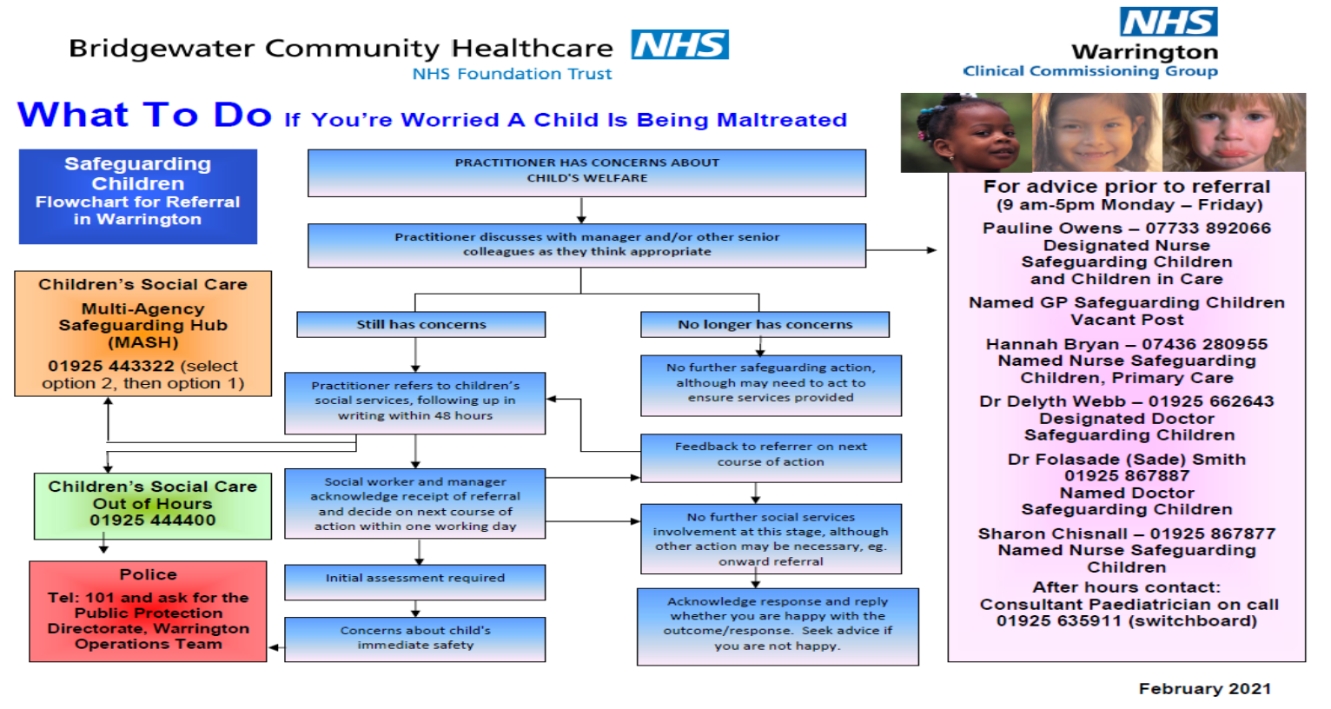

APPENDIX 2
WARRINGTON MULTI-AGENCY ASSESSMENT AND REFERRAL FORM

This joint-agency assessment and referral form should be used when an agency considers that a child has needs which cannot be met solely by that agency, and where co-ordinated intervention is required to promote, safeguard or protect the welfare of the child/children concerned

Completed by: ………………………………………………………….. Date:……..…..…….…………………..
Designation & Agency: ………………………………………………………….. ……………………………………..
Address of referrer: ……………………………………………………………………………….…..…….………………….
CHILD DETAILS:

Family surname(s) (or alias) ……………………………………………………………………………………….

Name(s) of child(ren) M/F DOB Nursery/School Ethnicity Religion

……………………………… ……. ……………. ………………… ………………… ……………
……………………………… ……. ……………. ………………… ………………… ……………
……………………………… ……. ……………. ………………… ………………… ……………
……………………………… ……. ……………. ………………… ………………… ……………

Address: …………………………………………………………………………………………………...….…
Parent’s first language:…………………………………Is an interpreter or signer required: …………

GP name & address: ……………………………………………………………… NHS no: ………....…………

FAMILY DETAILS:
Parents names (forename and family name/surname) DOB Parental responsibility

Mother: ………………………………………………. .……………….. Yes No

Father: ………………………………………………. ……………….. Yes No

Other significant adults in the household DOB Relationship & nature
Of care given
…………………………………………………………. ..…………..….. ….…………………………..

…………………………………………………………. ……………….. ……………………………...

Previous address of the family:
………………………………..…………………………………………………………………………………………..

If immediate protective action is required, a child protection referral must be made by telephone/visit to the local services office. This joint-agency form must be completed and forwarded to social services following the telephone referral. Within 48 hours a copy should also be sent to the referrer’s manager if agency procedure so requires.

Information on statutory status: Please give details:
Child/young person or other child(ren)/young person(s)
in family is/has been on a disability register: Yes / No ……………………..……………………………………

Child/young person has Statement of Educational Need Yes / No ………………………...………………………………...

Child/young person or other child(ren)/young person(s)
in family is/has been on a child protection register: Yes / No Category: ……………………………..………………...

Child/young person or other family member(s) has/
Have been looked after by a local authority: Yes / No ……………………..….………………………………...

Reason for referral to social services (please indicate if previous referrals have been made and attach any relevant information):

DETAILS OF OTHER AGENCIES INVOLVED WITH THE FAMILY/CHILD(REN):
Agency | Names | Address and tel no. | Current involvement

Summary of main areas of concern:
(to be completed by professionals who have access to the following information):
Child’s health and development:

Parenting skills:

Family and environmental factors:

Please outline the work undertaken by your agency to assist this child/family. Please also include any contact, which has been made with other agencies in respect of this referral, and provide details of any joint work.

ADDITIONAL INFORMATION:

What are the child’s views about this referral?

Does the child consent to the sharing of information between agencies? Yes No

What are the parents’ views about your concerns and this referral?

Please detail any special needs or circumstances of any family member, which may affect this referral or communication and understanding between the family and professional agencies.

I agree for this referral to be made to Social Services and understand that they will contact other agencies, including my doctor, my child’s school and health visitor, as part of the assessment.

Signed: ……………………………………………………………….(Parent/Carer) Date: …………………..

Signed: …………………………………………………… Designation: …………………………………………

Forwarded to: …………………………………………………….. Copy to: ………………………………………….

Date: ………………………………………………………………

Please return this form to: Warrington MASH (Multi Agency Safeguarding Hub), Ground Floor, Quattro Building, Warrington, WA1 2NJ.
Phone: 01925 443400. Email: childreferral@warrington.gcsx.gov.uk
Updated April 2016

RESPONSE OF SOCIAL SERVICES TEAM

Acknowledgement to be returned to the referring agency within seven working days

Name of child: ……………………………………………………………………………………………………………

Address: ……………………………………………………………………………………………………………

…………………………………………………………………………………………… postcode:………….

The needs of this child have been considered and the following action is to be taken.
Action | Comments (please give details)
No further action by social services.
Provision of information and advice.
Referral out to other agencies.
Initial assessment.
Provision of services under Section 17.

Core or specialist assessment required.
Initial Planning Meeting under Section 17.
Consideration under Child Protection Procedures under Section 47.
Other comments.

Copy to (Referring agency): ……………………………………………….. Date: ……………………………..

Signed: ………………………………………….……………………………… : ……………………………..

Name (print): ………………………………………………………….……….. Designation: …………………..……

Updated April 2016

